Project Initialization and Planning Phase

Date | 10 February 2026
Team ID | LTVIP2026TMIDS65419
Project Name | Flavour Fusion: Ai-Driven Recipe Blogging
Maximum Marks | 3 Marks

Define Problem Statements:
Therefore, food bloggers and busy individuals are in dire need of an easier way to pen or write a detailed recipe blog in the shortest length of time. Writing recipes manually requires a lot of efforts, creativities, and proper formatting that are really very time-consuming. Also, most of the recipes available online tend to be general and do not meet specific user needs. The result is usually frustration and reduced productivity. The Flavour Fusion application solves this problem by using an AI model to quickly generate customized and well-structured recipe blogs based on user input.

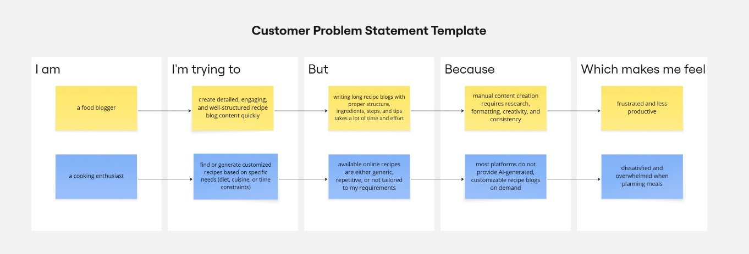

Problem  Statement  (PS) | I am | I’m trying to | But | Because | Which makes me feel
PS-1 | A food blogger | Create detailed, and high-quality recipe blog content in less time | Writing long and recipe blogs manually is time-consuming | It requires research, creativity, formatting, and consistency | Frustrated and less productive
PS-2 | A cooking enthusiast | Generate customized recipes | Existing recipes available online are generic and not customizable | Most platforms do not offer AI-driven recipe blog generation | Dissatisfied and overwhelmed while planning meals

